CYB 210 2-3 Activity: Packet Tracer
Andree Salvo
Southern New Hampshire University
Cyb 210
Instructor: Bruce Gonzalez
2025
- Modify the Marketing subnetwork.
- Create and populate the Advertising subnetwork.
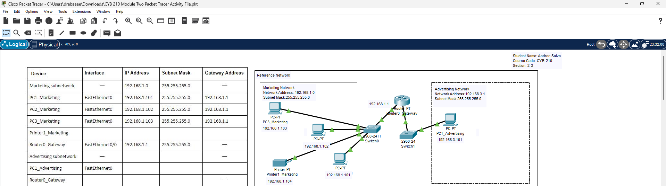

- Screenshot showing the result of executing the ping command from PC1_Marketing to PC3_Marketing.
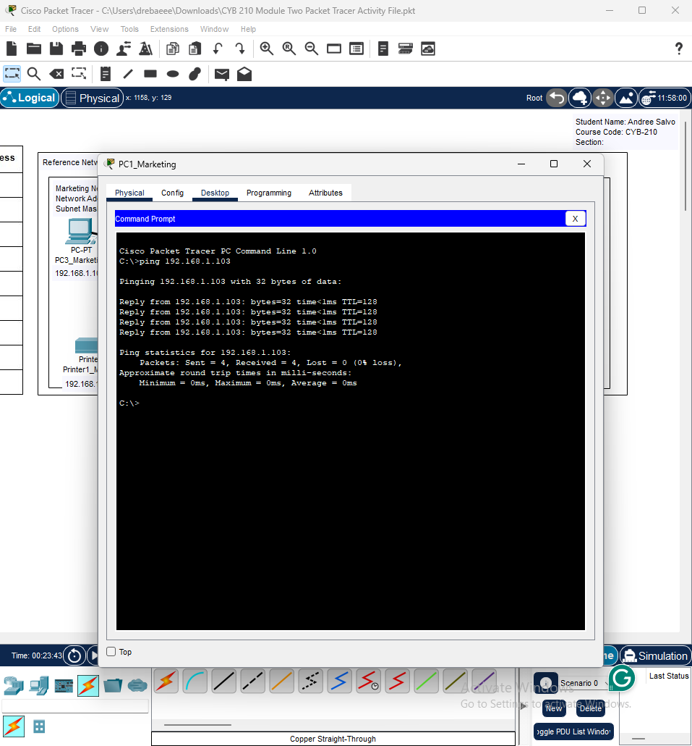

- Screenshot showing the result of executing the ping command from PC2_Marketing to Printer1_Marketing.
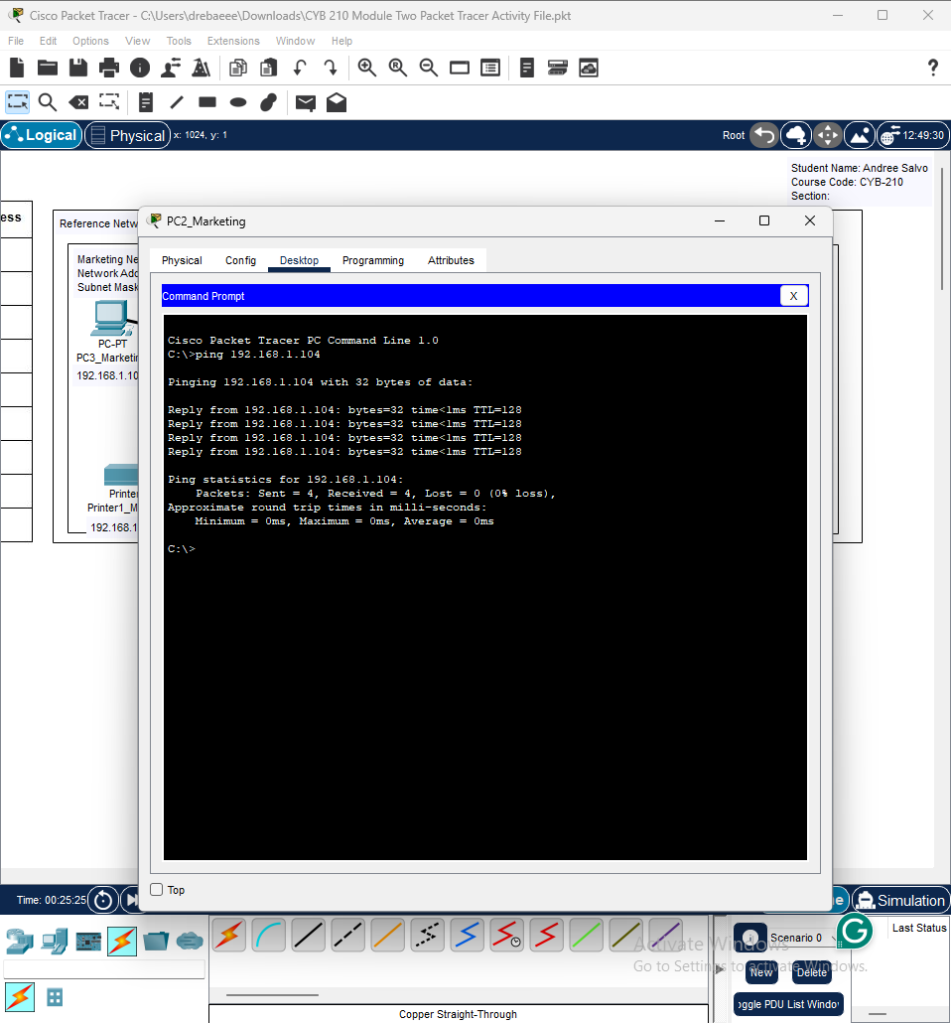

- Screenshot showing the result of executing the ping command from PC1_Advertising to PC1_Marketing.
